Full-Stack Assignment
Student Name: Jaswanth Damarla UID: 23BAI70650
Branch: AIT CSE-AIML Section/Group: 23AML-3(A)
Date of Performance: 06/02/26 Semester: 6th
Subject Name: Full Stack II Subject Code: 23CSH-382

Q1) Summarize the benefits of using design patterns in frontend development.

Ans) Benefits of Using Design Patterns in Frontend Development

Introduction

Frontend development has evolved rapidly with the growth of complex web applications, rich user interfaces, and large development teams. As applications scale, maintaining code quality, consistency, and performance becomes increasingly challenging. Design patterns offer proven, reusable solutions to commonly occurring problems in software design. In frontend development, they play a crucial role in building applications that are maintainable, scalable, and easy to understand.

1. Improved Code Reusability

One of the primary benefits of design patterns is code reusability. Patterns such as Component, Module, and Observer encourage developers to write reusable UI elements and logic. Instead of rewriting similar code across different parts of an application, developers can reuse existing patterns, reducing duplication and saving development time.

2. Better Maintainability and Readability

Design patterns provide a standard structure for solving problems. When developers follow familiar patterns, the code becomes easier to read and maintain. New team members can quickly understand the application structure because the patterns are well-known and documented. This reduces the learning curve and minimizes errors during maintenance or feature enhancements.

3. Scalability of Applications

As frontend applications grow in size and complexity, scalability becomes critical. Design patterns such as MVC (Model–View–Controller), MVVM, and Flux/Redux help organize code by separating concerns. This clear separation allows applications to scale smoothly without turning into tightly coupled and unmanageable codebases.

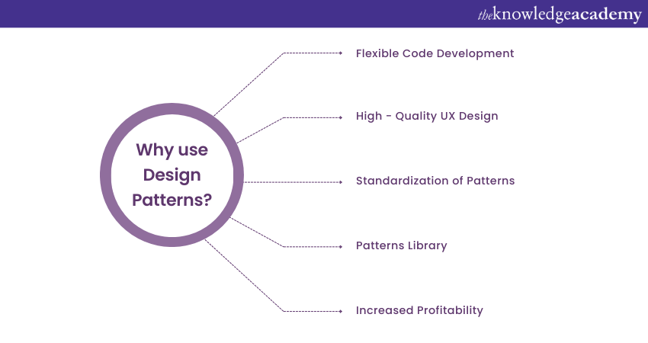

4. Consistency Across the Application

Using design patterns ensures consistency in coding style and architecture throughout the application. When similar problems are solved in similar ways, the overall structure of the frontend becomes predictable and uniform. This consistency improves collaboration among developers and reduces integration issues.

5. Easier Debugging and Testing

Frontend design patterns often promote loose coupling and modular design. This makes debugging easier because issues can be isolated to specific components or modules. Patterns also improve testability, as individual components can be tested independently using unit and integration tests.

6. Faster Development and Reduced Risk

Since design patterns are tried-and-tested solutions, they reduce the risk of design flaws. Developers do not need to invent new solutions for common problems, which speeds up development and ensures reliability. This leads to fewer bugs and more stable frontend applications.

Q2) Classify the difference between global state and local state in React.

Ans: Difference Between Global State and Local State in React

Introduction

In React applications, state is used to store and manage data that affects how components behave and render. Based on the scope and usage of this data, state in React is broadly classified into Local State and Global State. Understanding the difference between them is essential for building efficient, scalable, and well-structured React applications.

1. Local State

Local state refers to data that is owned and managed by a single component. It is used when the data is required only within that component and does not need to be shared with others.

Characteristics of Local State
• Stored inside a component using hooks like useState or useReducer
• Accessible only within the component where it is defined
• Simple and easy to manage
• Ideal for UI-related data such as form inputs, toggles, counters, and modal visibility

Example Use Cases
• Input field values in a form
• Button click counters
• Showing or hiding a dropdown or modal

Advantages
• Easy to implement and understand
• Improves component encapsulation
• Reduces unnecessary complexity

Limitations
• Cannot be directly shared across multiple components
• Leads to prop drilling when many child components need the same data

2. Global State

Global state refers to data that is shared across multiple components in an application. It is useful when different parts of the application need access to the same data.

Characteristics of Global State
• Stored at a higher level (context, store, or root component)
• Accessible by many components across the application
• Managed using tools like Context API, Redux, MobX, or Zustand
• Suitable for application-wide data

Example Use Cases
• User authentication details
• Theme (dark/light mode)
• Shopping cart data
• Language or localization settings

Advantages
• Avoids prop drilling
• Ensures consistency of shared data
• Easier to manage large-scale applications

Limitations
• Adds architectural complexity
• Can cause performance issues if not managed properly
• Requires careful state updates to avoid unwanted re-renders

3. Key Differences Between Local and Global State

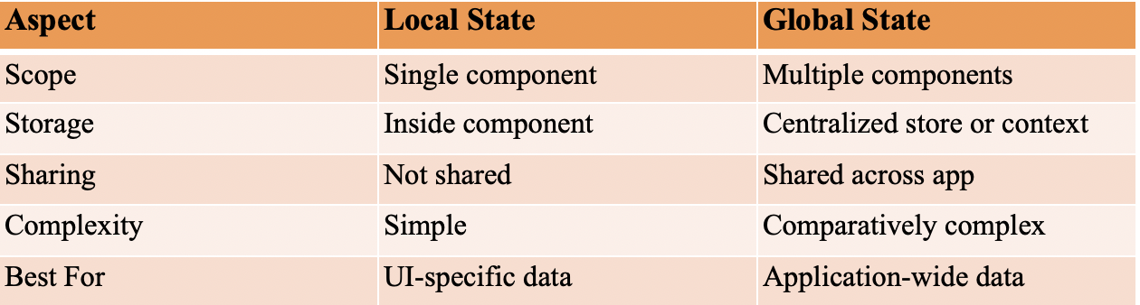

Q3) Compare different routing strategies in Single Page Applications (client-side, server-side, and hybrid) and analyze the trade-offs and suitable use cases for each.

Ans: Routing Strategies in Single Page Applications (SPA)

Introduction

Routing in Single Page Applications (SPAs) determines how different views or pages are displayed based on the URL without fully reloading the page. Unlike traditional multi-page applications, SPAs rely on various routing strategies to manage navigation efficiently. The three main routing strategies are Client-Side Routing, Server-Side Routing, and Hybrid Routing. Each approach has its own trade-offs and suitable use cases.

1. Client-Side Routing

Client-side routing is handled entirely in the browser using JavaScript. The server delivers a single HTML file, and navigation between pages is managed by frontend frameworks such as React Router, Angular Router, or Vue Router.

How It Works
• The browser loads one HTML page initially
• JavaScript updates the view based on URL changes
• No full page reload occurs during navigation

Advantages
• Fast navigation and smooth user experience
• Reduced server load after initial page load
• Ideal for highly interactive applications

Disadvantages
• Poor SEO without additional configuration
• Slower initial page load
• Requires JavaScript to be enabled

Suitable Use Cases
• Dashboards and admin panels
• Social media applications
- Web apps with frequent user interactions

2. Server-Side Routing

In server-side routing, each URL request is handled by the server, which returns a new HTML page. This is the traditional routing approach used before SPAs became popular.

How It Works
• Browser sends a request to the server for every route
• Server processes the request and sends a complete HTML page
• Page reload occurs on each navigation

Advantages
• Excellent SEO support
• Faster initial page load
• Works even if JavaScript is limited or disabled

Disadvantages
• Slower navigation due to full page reloads
• Higher server load
• Less dynamic user experience

Suitable Use Cases
• Content-heavy websites
• Blogs and news portals
• Static or informational websites

3. Hybrid Routing

Hybrid routing combines both client-side and server-side routing. The server renders the initial page, and subsequent navigation is handled on the client side. Frameworks like Next.js, Nuxt.js, and Remix support this approach.

How It Works
• Initial page is rendered on the server (SSR)
• After hydration, routing is handled by the client
• Combines SEO benefits with SPA performance

Advantages
• Good SEO with fast subsequent navigation
• Better performance and user experience
• Flexible and scalable architecture

Disadvantages
• Increased development complexity
• Requires careful configuration
• More learning curve

Suitable Use Cases
• E-commerce websites
• Public-facing applications
• Large-scale production apps

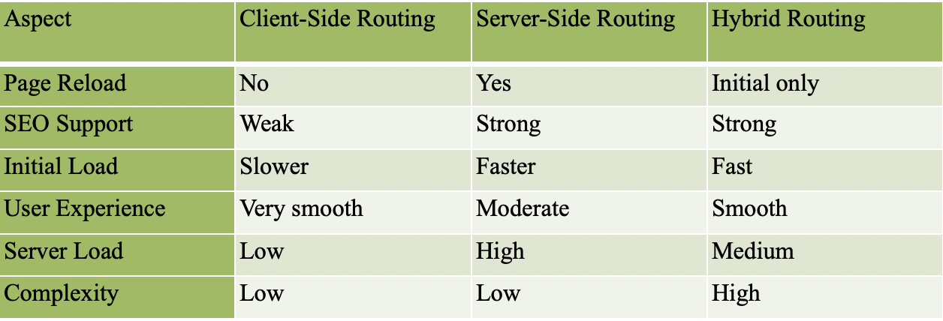

Q4) Examine common component design patterns such as Container–Presentational, Higher-Order Components, and Render Props, and identify appropriate use cases for each pattern.

Ans: Common Component Design Patterns in React

Introduction

In React, component design patterns help developers structure components in a clean, reusable, and maintainable way. As applications grow in complexity, following established patterns becomes essential to manage logic, presentation, and data flow effectively. Among the most commonly used patterns are Container–Presentational Components, Higher-Order Components (HOCs), and Render Props. Each pattern addresses specific problems and is suitable for different use cases.

1. Container–Presentational Pattern

The Container–Presentational pattern separates logic and data handling from UI rendering. This division improves readability, testability, and reuse of components.

Container Components
• Handle business logic, state management, and data fetching
• Pass data and callbacks to presentational components via props
• Usually do not contain much JSX for UI

Presentational Components
• Focus only on UI and layout
• Receive data via props
• Do not manage application state

Advantages
• Clear separation of concerns
• Easier to test UI independently
• Improves code maintainability

Limitations
• Can lead to more files and boilerplate
• Less common in modern React due to hooks

Suitable Use Cases
• Large applications with complex logic
• Teams with designers and developers working separately
• Reusable UI components (buttons, cards, forms)

2. Higher-Order Components (HOCs)

A Higher-Order Component is a function that takes a component as input and returns an enhanced component. It is mainly used to reuse component logic across multiple components.

Key Characteristics
• Reuses logic such as authentication, logging, or data fetching
• Does not modify the original component
• Wraps the component with additional behavior

Advantages
• Promotes code reuse
• Keeps components DRY (Don’t Repeat Yourself)
• Useful for cross-cutting concerns

Limitations
• Can make component trees harder to debug
• Naming conflicts and prop collisions
• Less intuitive for beginners

Suitable Use Cases
• Authentication and authorization checks
• Logging user interactions
• Injecting common props or behaviors

3. Render Props Pattern

The Render Props pattern involves passing a function as a prop to a component, which determines what should be rendered. This function receives shared logic or state from the component.

Key Characteristics
• Uses a function to control rendering
• Shares logic without inheritance or wrapping
• Highly flexible pattern

Advantages
• Powerful and flexible logic sharing
• Avoids component wrapping issues
• Clear data flow

Limitations
• Can reduce readability if overused
• JSX can become complex and nested
• Slight performance overhead

Suitable Use Cases
• Sharing mouse position or window size logic
• Custom reusable behaviors
- Advanced UI interactions

4. Comparison of Component Design Patterns

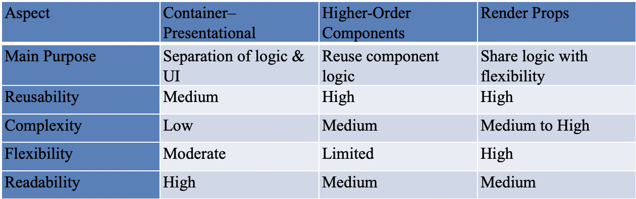

Q5) Demonstrate and develop a responsive navigation bar using Material UI components while applying appropriate styling and breakpoint configurations.

Ans: To design and implement a responsive navigation bar using Material UI (MUI) in a React application that adapts to different screen sizes using breakpoints.

Material UI provides pre-built responsive components such as:
• AppBar – For top navigation
• Toolbar – To arrange items inside AppBar
• IconButton – For menu icons
• Drawer – For mobile navigation
• useTheme & useMediaQuery – For breakpoint-based responsiveness

Responsive Behavior
• Desktop (md and above): Menu items are displayed horizontally.
• Mobile (sm and below): Menu items are hidden and replaced with a hamburger menu that opens a Drawer.

A navigation bar is an essential user interface component that provides quick access to different sections of a web application. In modern web development, applications are expected to be responsive, meaning they should adapt seamlessly to various screen sizes such as desktops, tablets, and mobile devices.

Steps to Implement:

Step 1: Create a React Application

Create a new React application using a build tool such as Vite or Create React App. Open the project folder in Visual Studio Code.

Step 2: Install Material UI Dependencies

Install Material UI core components, icons, and styling dependencies using the following command:

npm install @mui/material @mui/icons-material @emotion/react @emotion/styled

Step 3: Import Required Components

Import necessary Material UI components such as AppBar, Toolbar, Typography, Button, IconButton, Drawer, and layout utilities in the App.jsx file.

Step 4: Create the Navigation Bar Structure

Use the AppBar component to create the top navigation bar and the Toolbar component to arrange navigation elements like the website logo and menu items.

Step 5: Define Menu Items

Create an array of menu items (for example: Home, About, Services, Contact) and render them dynamically using the map() function.

Step 6: Implement Responsive Behavior

Use Material UI’s useMediaQuery hook along with predefined breakpoints to detect screen size. Display horizontal menu buttons for desktop screens and a hamburger menu icon for mobile screens.

Step 7: Add Mobile Drawer Menu

Use the Drawer component to create a side navigation panel for mobile view. Open and close the drawer using React’s useState hook.

Step 8: Apply Styling and Layout Control

Use Box, Container, and sx properties to manage spacing, alignment, and overall layout. This ensures a clean and balanced user interface.

Step 9: Prevent Content Overlapping

Since the navigation bar is fixed at the top, add a Toolbar spacer below the AppBar to prevent content from hiding behind it.

Step 10: Run and Test the Application

Run the application using npm run dev and test the navigation bar on different screen sizes to verify responsive behavior.

Example Code: (App.jsx):
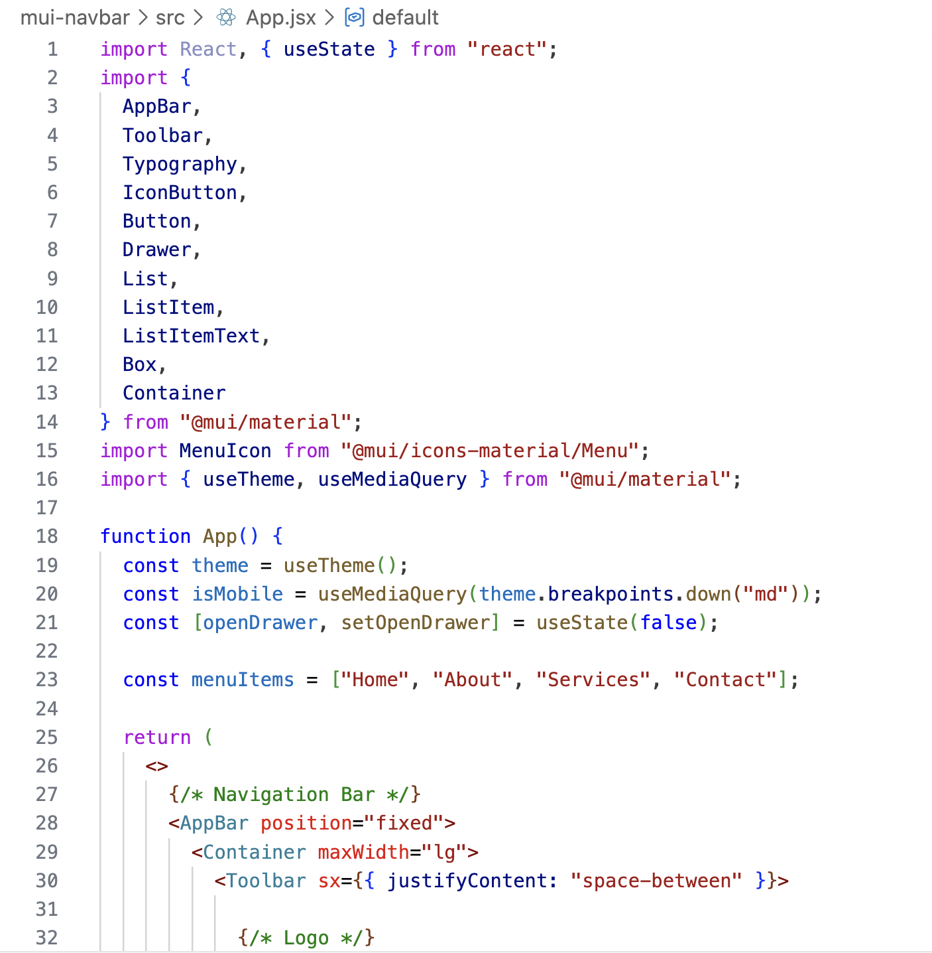

Output:


Material UI (MUI) is a popular React-based UI framework that follows Google’s Material Design principles. It provides pre-built components such as AppBar, Toolbar, Button, IconButton, and Drawer, which help in building responsive and visually consistent user interfaces with minimal effort.

Q6) Evaluate and design a complete frontend architecture for a collaborative project management tool with real-time updates. Include: a) SPA structure with nested routing and protected routes b) Global state management using Redux Toolkit with middleware c) Responsive UI design using Material UI with custom theming d) Performance optimization techniques for large datasets e) Analyze scalability and recommend improvements for multi-user concurrent access.

Ans: Frontend Architecture for a Collaborative Project Management Tool with Real-Time Updates

Introduction

A collaborative project management tool (similar to Jira, Trello, or Asana) requires a robust frontend architecture to handle real-time updates, multiple users, large datasets, and responsive user interfaces. The frontend must be scalable, maintainable, and performant while providing a smooth user experience. This section evaluates and designs a complete frontend architecture addressing routing, state management, UI design, performance optimization, and scalability.

a) SPA Structure with Nested Routing and Protected Routes

SPA Structure

The application is built as a Single Page Application (SPA) using React. The SPA structure ensures smooth navigation without full page reloads and supports real-time collaboration.

High-level structure:
• /login – Authentication page
• /register – User onboarding
• /app – Protected root layout
• /app/dashboard – Overview of projects
• /app/projects – List of all projects
• /app/projects/:projectId – Project workspace
• /board – Kanban board
• /tasks – Task list view
• /members – Team management
• /app/settings – User settings

Nested Routing

Nested routing (using React Router) allows child components like boards, tasks, and members to render within a shared project layout. This improves modularity and UI consistency.

Protected Routes

Protected routes ensure that only authenticated users can access project data. Authentication state is checked before rendering routes, and unauthenticated users are redirected to the login page.

Benefits:
• Secure access control
• Clean separation between public and private routes
• Better user flow management

b) Global State Management Using Redux Toolkit with Middleware

Why Redux Toolkit

Redux Toolkit (RTK) provides a standardized and efficient way to manage global state such as user authentication, project data, tasks, notifications, and real-time updates.

State Structure
• authSlice – User credentials, tokens, roles
• projectsSlice – Projects and metadata
• tasksSlice – Tasks, status, assignments
• uiSlice – Theme, modals, loaders
• realtimeSlice – WebSocket events and sync status

Middleware Usage
• Redux Thunk / RTK Query – For async API calls and caching
• WebSocket Middleware – To handle real-time updates (task changes, comments, status updates)
• Logger Middleware (dev) – For debugging during development

Advantages:
• Predictable state updates
• Centralized data flow
- Easy debugging and scalability

c) Responsive UI Design Using Material UI with Custom Theming

Material UI Components

Material UI (MUI) is used to ensure consistency, accessibility, and responsiveness across devices.

Key UI Elements:
• AppBar + Drawer for navigation
• Cards for tasks and projects
• Dialogs for task creation and edits
• Tables and lists for large datasets

Responsive Design
• Breakpoints (xs, sm, md, lg) for adaptive layouts
• Drawer switches between permanent (desktop) and temporary (mobile)
• Grid system for flexible layouts

Custom Theming

A custom MUI theme defines:
• Primary and secondary colors
• Typography styles
• Dark and light mode support
• Consistent spacing and component styling

Benefits:
• Unified visual identity
• Better accessibility
- Improved user experience

d) Performance Optimization Techniques for Large Datasets

Handling large datasets such as thousands of tasks and activities requires careful optimization.

Techniques Used
• Virtualization (e.g., windowed lists) to render only visible items
• Pagination & Infinite Scroll for task lists
• Memoization (React.memo, useMemo, useCallback) to prevent unnecessary re-renders
• Normalized Redux State to avoid deep nesting
• Code Splitting & Lazy Loading for routes and heavy components

Real-Time Optimization
• Batched updates from WebSocket events
• Debouncing frequent updates
• Selective state updates instead of full re-renders

e) Scalability Analysis and Recommendations for Multi-User Concurrent Access

Scalability Challenges
• Multiple users updating the same project simultaneously
• Real-time synchronization conflicts
• Increasing number of projects and tasks

Frontend Scalability Strategies
• Use WebSockets or WebRTC for real-time collaboration
• Optimistic UI updates with rollback on failure
• Role-based access control (RBAC) at UI level
• Efficient caching with RTK Query

Recommended Improvements
• Introduce micro-frontend architecture for very large teams
• Implement event-driven updates instead of polling
• Add offline support with background sync
• Improve concurrency handling using versioning or timestamps

